**Manage your Daily Sales Meetings on a CRM Platform**

According to stats by Oxford Economics department, face-to-face sales meetings are still more effective for a deal closure than virtual meetings by over 85%.

With keeping this data in mind, it makes sense that companies should try to arrange maximum number of customer meetings in all feasible ways.

Even as the face-to-face sales meetings are definitely more productive, they can only be conducted at the convenience of both sales person and a willing prospect. It’s enough to consider the pure economics of time and transit costs involved to make you scramble for an alternate sales strategy.

In this situation, you need to have a smarter way of arranging meetings and transits. This helps you to arrange more meetings and meet your specific sales targets.

The CRM-based Mobile meeting arrangement is an ideal way to plan and arrange these meetings. This helps you simulate a better plan to meet maximum number of prospects within a given timeline.

A CRM-based Mobile meeting management system lets you set and align meetings across the relevant geography. This system allows you to utilize every opportunity for arranging potential sales meetings.

This may appear to be a lofty claim. With customer’s apprehension, you may ask the following question.

*Very well, but how can it help me to create opportunistic meetings with real sales prospects?*

Wait, let us explain.

**Challenges in managing Pre-sales and Deal Closure Meetings**

An experienced sales manager knows that the path to final deal closure meeting is long and winded.

*Sometimes, a prospect may take up-to five preparatory meetings before the prospects make the final decision to close or drop the entire sales exchange.*

This could put even the most confident sales managers into a state of constant contemplation about their field approach.

Can I remotely manage the field efforts?

Should I accompany meetings?

Where is my best opportunity?

This usually includes the introductory meeting, pitching meeting and negotiation meeting. Needless to say, this deal closing procedure is time consuming and often confusing. Sometimes, you may even lose track of where you stand with every sales prospect.

In these meetings, you are also required to manage and consolidate objectives of every sales team.

**How CRM helps you marshal the challenges of every meeting?**

As indicated earlier, managing sales meetings are about arranging maximum number of meetings within a given amount of time and energy. This requires you to arrange meetings and handle client commitments across the city. Simultaneously, you also need to set specific objectives for each sales meeting.

SaaS based Mobile CRM system is best suited to meet this objective. It helps you open-up clear communication channel with every prospect over the geography.

This helps you open-up integrated communications between the management and sales personnel at the field attending meetings. This helps you manage clear communication channels with each and every field employee.

It allows you to make sure that you aren’t just stuck at communicating motivational messages.

**Realizing an Optimal Meeting Pattern**

Before arranging a sales meeting, you may need to answer multiple questions.

Can I possibly have my best option attending the critical meetings? Will this prospect need more technical answers? Could there be a better meeting pattern?

The success of a good sales manager lies at finding the right answers to maximum number of these questions.

A CRM platform lets you simulate a plan to cover maximum geography and maximize your meeting attendance.

**Mobile Location Tracking and Reporting**

A Mobile CRM should be able to objectively figure out a meeting pattern that realizes maximum number of meetings across the geography. For this, you need to have a daily plan that reaches maximum number of prospects within given working hours.

The SaaS mobile system lets you track employee location across the geography. Letting you know about the current location of an employee at any given time.

Further, this lets you simulate a plan to arrange maximum number of meetings across the geography. By plotting the transit routes of each field employee, you can leverage possible meetings for each employee.

**Aligning Specific objective for every meeting**

Rather than having another fluffy conversation, every sales meeting should have a definite objective. The end success or failure could be determined by the outcome of each meeting.

Without an objective, you may come out of every meeting without achieving anything special, but feeling ecstatic about the entire ordeal.

Alternatively, you can set specific goals for each meeting which combines to form timeline for your ongoing sales meetings.

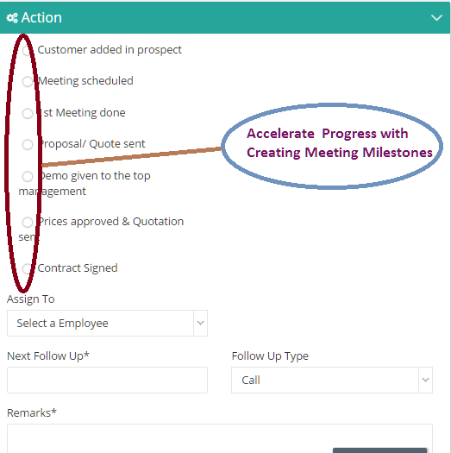

This makes customer communication a part of every potential sales meeting.

**Non-intrusive but efficient communications**

The Mobile CRM platform helps you manage non-intrusive communications within the CRM platform.

The function of a sales manager is to be supportive or provide sufficient inputs to the role of sales management. A mobile CRM platform lets you have non-intrusive means of communication for every customer portal.

**Conclusion:-**

If your client portfolio is spread across the city, maximizing your customer exposure without burning out your field employees can be anything but easy. The SaaS mobile tracking system lets you create a smart visual plan to arrange meetings across geography.

To learn more about CRM location tracking system, contact us @ +91-7899887755 or [sales@kapturecrm.com](mailto:sales@kapturecrm.com)