**Three guiding points for CRM-based Realtor Marketing Management**

For any real estate agency, there are two aspects of business that needs to be constantly attended and improved– prospect handling and finance management. With increasing industry competitiveness, the level of agility of these aspects could easily determine the success or failure of your business.

Here, a realtor agency should be able to build and leverage their trust and timeliness. If you are late on opportunities or customers grow distrustful, even a high lead count will only mean lost opportunities.

With a CRM-based Realtor Marketing, you can address these multiple aspects to achieve optimal results. Here are three guiding activities to help you proficiently manage your marketing responsibilities.

**Diversify and Integrate Campaign Channels**

A real estate market needs to be operated on a locally focused marketplace. It means that all operations are run focusing on the needs and requirements of local customers.

In-order to realize this, you may need to run multiple campaigns that can possibly reach out to your audience. For this, you need to advertise your business on multiple mediums used by your audience.

For this, you need to prioritize your ad budgeting to be spent on multiple streams. As usage of multiple platforms get varied according to time and trend, you are required to be on the constant lookout for the effects of multiple marketing streams.

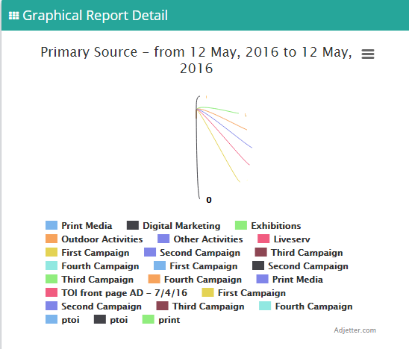

This enables you to maximize the effect of your advertising expenditure through selecting and focusing on right marketing channels with optimal returns.

**Manage Agents or Referral Campaigns**

In-order to run a realtor agency, you should be able to provide the right financial incentives based on performance.

For example, associated with each customer you can assign a particular agent or employee. In the future, you can evaluate the contributions of each resource. Based-on this data, you can decide whether to carry forward the relationship into future.

This data comes particularly useful when you are handling recurring payment such as rolling commissions or referrals. You can instantly retrieve **CRM-based reports**toattribute payments and collections.

Combined with ability to filter employee / agent leads, you can collect andsegment your prospect database.

**Long-term Prospect and Contact Management**

Any-one with two month experience in reality business knows that leads have long gestation period. Itsimply means that they go through a long-period of lead nurturing before finally getting converted.

Let’s consider an average prospect in the high-investment realtor market, who would have already contacted multiple builders. Here, you can stay relevant only through long-term prospect management.

A CRM helps you derive a realistic conversion funnel, by integrating various aspects of prospect management. You can segment each lead according to their chances of conversion as Hot, Warm and Cold.

In-order to successfully market your realtor products, you need to have the right tools and applications at your disposal. Learn more about CRM software for realtor @ +91-7899887755 or [sales@kapturecrm.com](mailto:sales@kapturecrm.com)